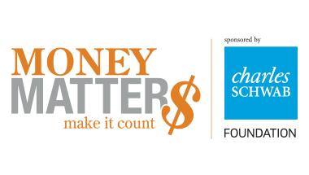

Money Matters promotes financial responsibility and independence among Club members ages 11 to 18.

Young adults in the U.S. today are facing a perfect storm of personal and social pressures that can compromise their financial well-being: record lows in savings, record highs in student and consumer debt, increasing living costs and uncertain employment prospects. Money Matters helps young people learn financial literacy, so they can make good financial choices as adults. Participants learn how to manage a checking account, create a budget, save and invest, start small businesses and pay for college. Teens who complete Money Matters show improved financial management skills, including saving money and sticking to a budget.Please return to Shawn Fleurie or Front Desk Attendant to register for program. This program is at no charge and is a core Boys & Girls Club program. Program Starts
_________________________________ ____________ ____________
Members Name Grade Date of Birth

Please List any allergies: ____________, ______________, ______________, _____________

_________________________________ ________________ ____________
Parent/Guardian’s Name (Please print) Signature Today’s Date

_______________________________ ________________ ___________
Home Phone Work Phone Cell Phone

EMERGENCY CONTACT INFORMATION

In case of emergency please contact:

________________________ _______________________ ________________
Name Relationship Phone

_____________________ ____________________ _________________
List any Allergies

*In case of an emergency involving my child, I give permission for the Boys & Girls Club of Webster - Dudley staff to seek emergency medical treatment for my child and to act as guardian in permitting medical treatment if unable to reach me.

I understand that all emergency and/or medical costs are my responsibility.

___________________ _________________________ ________________
Parent/Guardian Name Signature Date

